Spencer Olive

CIT 241

Brother Stokes

Network Proposal for Dunder Mifflin

The following is the network proposal for Dunder Mifflin. The design will support their three-story office with 100 users in Scranton. The first floor will consist of the marketing (25 users), IT (5 users), and Accounting Department (5 users) and will also contain the server room. The second floor will be comprised of the Sales Department (50 users). The third floor will be comprised of the Executive Offices and the HR Department (5 users each). For redundancy we have decided to go with a hierarchical network design. This means that all systems will have multiple ways to access the network limiting downtime in the case of disruptions. This will also ensure that there are capabilities to add users to the network easily in the future. Each floor will have wireless access points for each floor as well as a guest access point that will be on its own separate network.

**Diagram:** This diagram is for representational purposes only. Many of the devices will be located in the server room. This just gives you an idea of how the network will connect.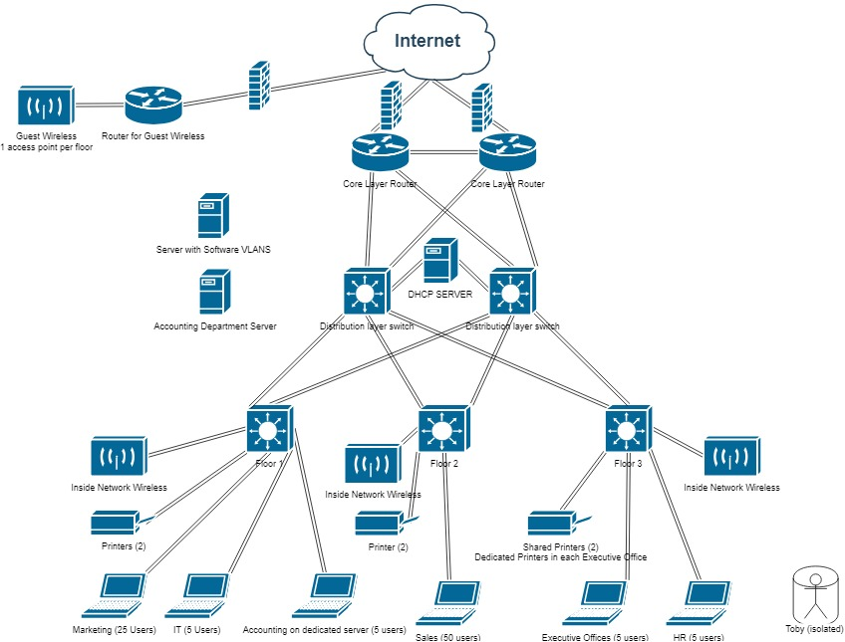

**Equipment and Labor Cost:**

|  |  |  |  |  |
| --- | --- | --- | --- | --- |
| **Equipment** | **Model** | **Quantity** | **Individual Price** | **Each totaled price** |
| Access switches | **Cisco Catalyst 3650-12X48UR-S Switch** | 3 | $8,916.99 | $26,750.97 |
| Distribution switches | **Cisco Catalyst 6503-E Switch** | 2 | $2,740.45 | $5,480.90 |
| Core Routers | **Cisco Router** | 3 | $516.00 | $1,548.00 |
| Network Firewall | **Cisco ASA5508-K9** | 3 | $1283.00 | $3,849.00 |
| Wireless access point | **Cisco Aironet wireless** | 6 | $600.00 | $3,600.00 |
| Ethernet cabling | **Cat5e Bulk 1000ft Ethernet Cable White** | 2 | $36.50 | $73.00 |
| Servers | **Cisco Servers/Rack** |  | $1,500.00 | $1,500.00 |
|  |  |  | Total | $42,801.87 |

**Labor**

|  |  |  |  |
| --- | --- | --- | --- |
| Labor performed | Hours | Hourly rate | Price |
| Wiring | 10-20 | $70 | $700-$1400 |
| Configuration | 8-18 | $120 | $960-$2160 |
|  |  | Labor Total | $1,660.00-  $3,560 |
|  |  |  |  |

|  |  |
| --- | --- |
| **Estimate Total** | **$45,000-50,000** |

**VLAN / IP Addresses:**

Each area of the network will have its own separate VLAN. All of these will be software VLANS with the exception of Accounting which for security reasons will have its own server. To save on costs we will use NAT which allows us to have less public IP addresses. All of the workstations inside the network can have their own private IP address that will transition to a public IP address through the router with NAT. An example of the addresses we could use is in the following table.

|  |  |
| --- | --- |
| **Department** | **IP range** |
| Marketing | 192.168.1.0 – 192.168.1.255 |
| IT | 192.168.1.0 – 192.168.1.255 |
| Sales | 192.168.1.0 – 192.168.1.255 |
| Executive Offices | 192.168.1.0 – 192.168.1.255 |
| Human Resources | 192.168.1.0 – 192.168.1.255 |
| Accounting | 192.168.1.0 – 192.168.1.255 |

These would be the available IP’s for these departments. This allows for future expansion up to 255 workstations in each department.

**Conclusion:**

This network as depicted should be sufficient for the company as well as be capable of easily expanding for future growth. We look forward to working with you.

Appendix

**What network design pattern did you use for your proposal? Why did you choose that pattern? Have you explained in your proposal the benefit of the design you are recommending?**

I used a three-level hierarchal design with a core, distribution and access layer. This is ensuring redundancy so there won’t ever be a single point of failure taking down the entire system.

**Are you recommending the use of NAT? Why?**

I recommended NAT because they will want to access the internet and NAT will ensure they have a proper internet IP address without having each workstation needing their own online IP. This will reduce costs.

**What internal routing protocol(s) are you recommending? Why did you select the protocol(s) you did?**

EIGRP as I am recommending Cisco Equipment. This should quickly and efficiently propagate any changes that may happen to the network.

**What protocol(s) are you using to connect with the ISP? Why did you select the protocol(s) you did?**

BGP as it is very configurable and should be very suitable for this connection.

**How are you addressing the security requirements?**

The network will have a firewall to help increase security. We are also implementing the VLANs per the requirements (isolating the accounting department)

**How are you addressing the potential need for future expansion?**

Using the three-level hierarchical design it will be easy to add, remove and replace additional hardware as needed. The hardware that I have recommended will also allow for added connections for additional workstations in the near future without upgrading hardware.

**Are you confident in the resiliency of your proposed network design? What design elements will provide the resiliency?**

We have created redundancy in the plan, added the security measures that we thought would be best suited for the network and created VLANs to isolate areas of the network from each other. The server room is locked and the keys have been given to upper management to distribute only to trusted individuals. We had a special request to never give a key to Toby as he can’t be trusted. In this way the network should be resilient to system failure and outside or inside malicious attacks.